*Post Office directory: B (no pubid)*

|  |  |
| --- | --- |
|  |  |
| Filename | post-offce-b.xml |
| XML encoding statement | <?xml version="1.0" encoding="iso-8859-1" standalone="no"?> |
| DTD reference | <!DOCTYPE report SYSTEM “dtd/report.dtd” |
| XSL stylesheet reference | do not include |
| italic | <i> |
| bold | <b> |
| Small caps | Key as ordinary capitals |

Please key from Baalzephon st (page 165) up to Cable st (page 210).

The structure of the text is quite complicated so please ask us if you have any questions. Please also feel free to use /?/ for tagging at a point where you are unsure if your interpretation is correct.

The directory is divided into streets, with street names in bold. Please capture each street as a list with the name of the street inside a head element.

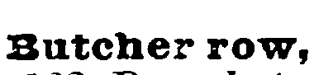

<head>Butcher row</head>

Please capture the text which follows the street name, which is non-bold text, in a head2 element, leaving the comma between head and head2:

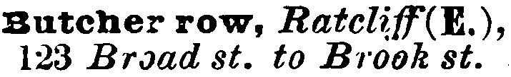

<head>Butcher row</head>, <head2><i>Ratcliff</i> (<b>E.</b>), <i>123 Broad st. to Brook st.</i></head2>

head2 is followed by a map reference. Please key this within a map element.

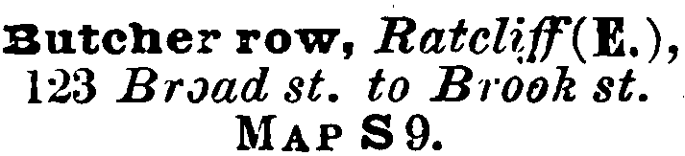

<head>Butcher row</head>, <head2><i>Ratcliff</i> (<b>E.</b>), <i>123 Broad st. to Brook st.</i></head2>

<map>MAP S9.</map>

After the map reference, lines that do not begin with ellipses should be captured as list items, li:

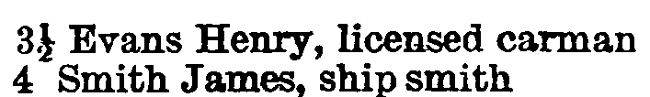

<li>3&frac12; Evans Henry, licensed carman</li>

<li>4 Smith James, ship smith</li>

Items which do not begin with a number are indented one tab stop: these are also list items:



<li>ST. JAMES’S CHURCH</li>

However lines indented further than this are part of the list item above. Please use a line break between these lines unless there is a hyphen indicating a carried over word; capture using one li:

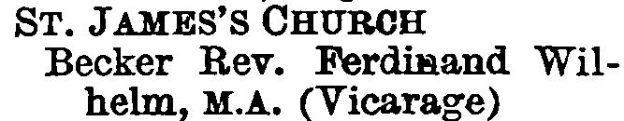

<li>ST. JAMES’S CHURCH<br />Becker Rev. Ferdinand Wilhelm, M.A. (Vicarage)</li>

Lines that begin and end with an ellipsis should be captured in the element xst. These words are in italics. Please do not capture the ellipses or use the italic element:



<xst>here is Brook street</xst>

So the complete capture for Butcher row on page 210 would be:

<head>Butcher row</head>, <head2><i>Ratcliff</i> (E.), <i>123 Broad st. to Brook st.</i></head2>

<map>MAP S9.</map>

<li>3&frac12; Evans Henry, licensed carman</li>

<li>4 Smith James, ship smith</li>

<li>ST. JAMES’S CHURCH<br />Becker Rev. Ferdinand Wilhelm, M.A. (Vicarage)</li>

<xst>here is Brook street</xst>

<li>10 Boik Thomas, brassfounder</li>

<li>10&frac12; Symons John &amp; Co. cider mers</li>

<li>14 Lonsdale Joseph, groce</li>

<xst>here is Brook street</xst>

<li>1A, Jones &amp; Mason, methylated spirit makers</li>

<li>Brown John &amp; Robt. B. shipwrghts</li>

<xst>here is Bere street</xst>

<li>27 Beavis William, coffee rooms</li>

<li>30 Cooper Mrs. Caroline, carman</li>

</list>

Some streets also have a ‘side’, with *north*, *south*, *east* or *west*, followed by *side*, in small caps. Please capture these in the element side within the list structure (at the same level as the li element):

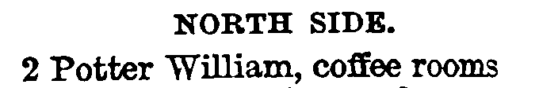

<side>NORTH SIDE.</side>

<li>2 Potter William, coffee rooms</li>

Some list items are grouped by braces. If the brace is on the left-hand side of the column please repeat the information before the brace before each list item:

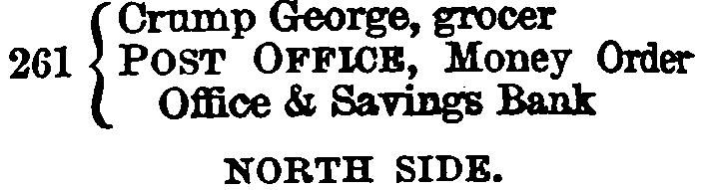

<li>261 Crump George, grocer</li>

<li>261 POST OFFICE, Money Order Office &amp; Savings Bank</li>

<side>NORTH SIDE</side>

If the brace is on the left-hand side of the column please repeat the information after the brace after each list item:

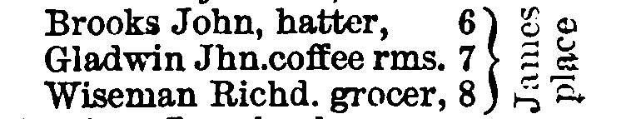

<li>Brooks John, hatter, 6 James Place</li>

<li>Gladwin Jhn. Coffee rms 7 James Place</li>

<li>Wiseman Richd grocer, 8 James Place</li>